Improving Deep Neural Networks

COURSERA

Andrew NG

目录
1. Practical aspects of Deep Learning 3
Train/dev/test sets 3
Bias/variance 4
Basic recipe 4
Regularization 5
Logistic regression example 5
L2 in Neural network 6
Why help overfitting 6
Dropout 6
Data augmentation 7
Early stopping 7
Normalizing inputs 7
Vanishing/exploding gradients 8
Numerical approximation of gradients 9
2. Optimization algorithms 9
Mini-batch gradient descent 9
Exponentially weighted average 10
Gradient descent with momentum 11
RMSprop 11
Adam 11
Learning rate decay 12
Local optimum 12
3. Hyper parameter tuning 13
Tuning process 13
Using appropriate scale to pick hyperparameters 14
Parameters search in practice: pandas vs caviar 14
Normalizing activation (Batch-norm) 15
why batch-norm works? 15

Practical aspects of Deep Learning

Train/dev/test sets
- Iterative process
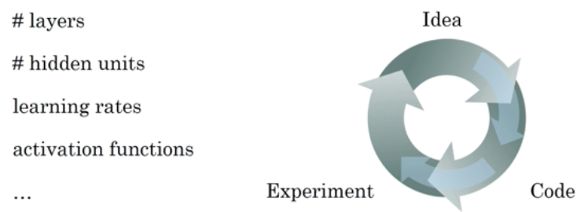
- Tips of three sets
About size:
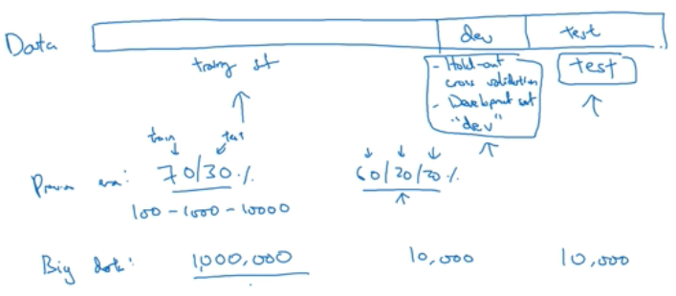
Dev and test from same distribution:
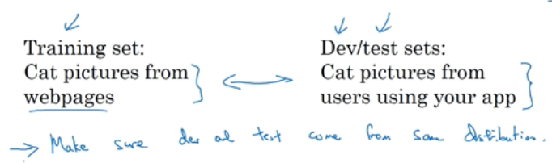

Bias/variance
- Intuition
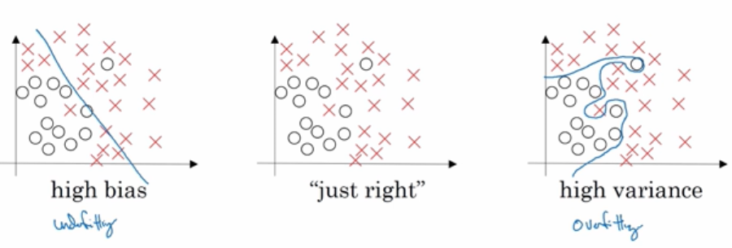
- Concept
Bias: training set error – Bayes Optimum
Variance: training set error – dev set error

Basic recipe
- Problems and solutions
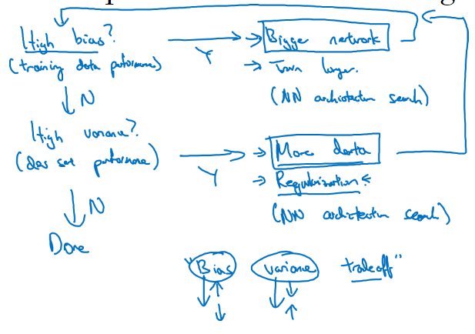

Regularization

Logistic regression example
- Lasso regression (L1 regularization)
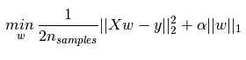
Where α = λ / n

- Ridge regression (L2 regularization)
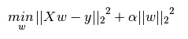
Where α = λ / 2n

- We always omit regularization for bias ‘b’, which has similar form with that for ‘w’
- λ is called regularization parameter, which is another HYPER-PARAMETER to be determined through dev sets.

L2 in Neural network
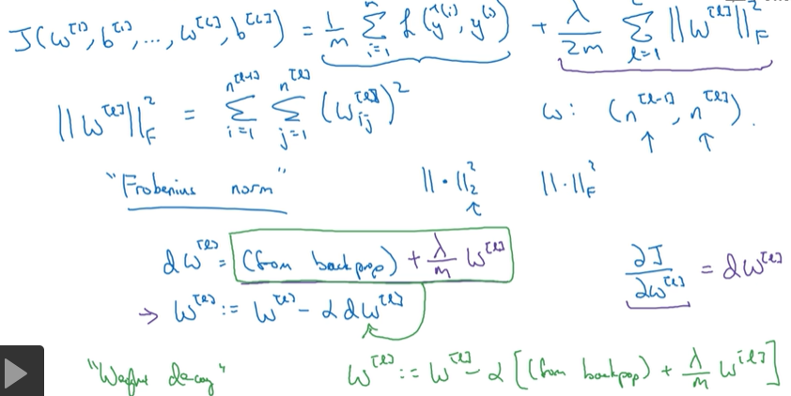

Why help overfitting
- intuition
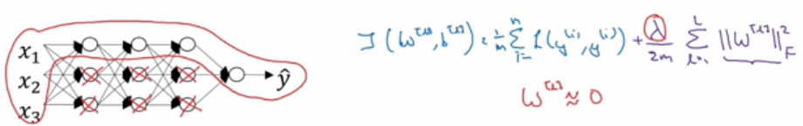
Reduce ‘w’ matrix and minimize some nodes to be 0 and thus make network simpler

For activation function:
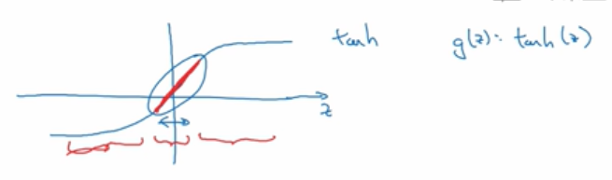
When w ≈0, activation is close to linear. When every layer is linear, the model is linear and simple.

Dropout
- implementation
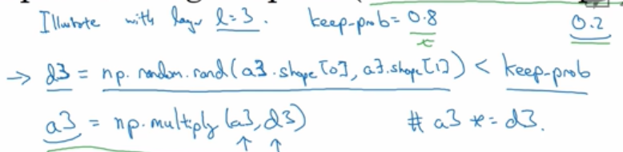
- inverted dropout
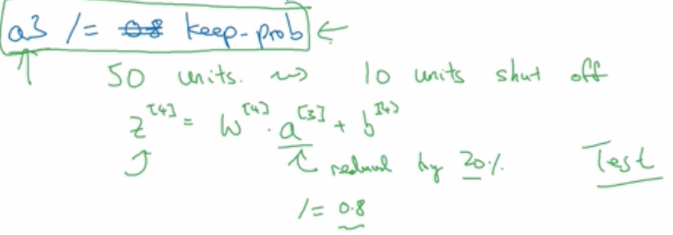
Ensure overall expectation is unchanged.
- Why it works
Intuition: cannot rely on any one feature, so have to spread weight – similar to ‘shrinking weights’
- Disadvantage
No well-defined cost functions

Data augmentation



Early stopping
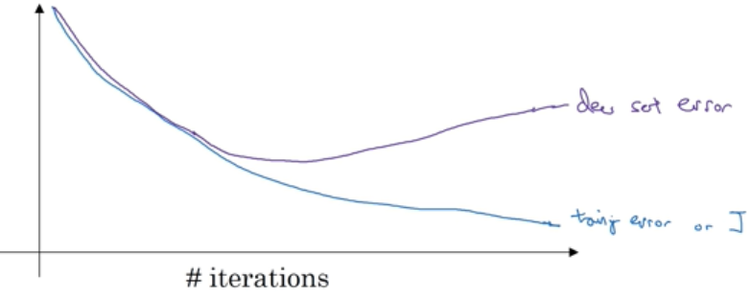

Normalizing inputs
- Two steps
Put mean to 0 -> same variance in all directions
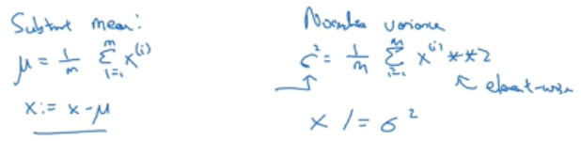
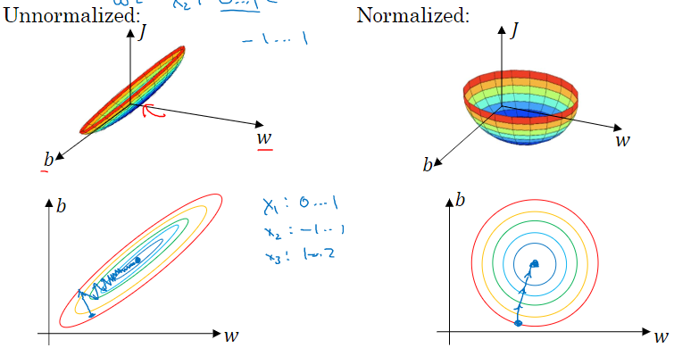

Vanishing/exploding gradients
- Intuition
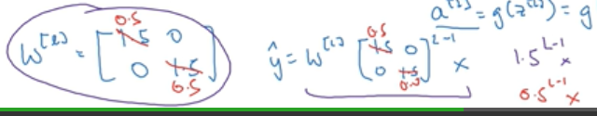
- Solution: weight initialization
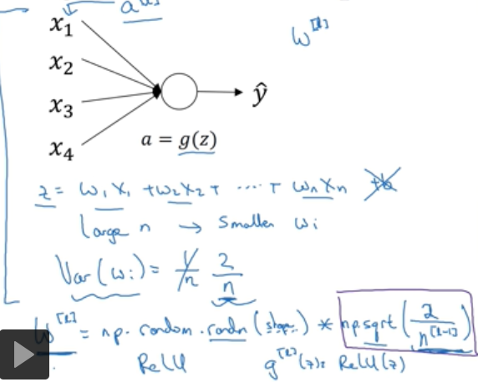

Numerical approximation of gradients
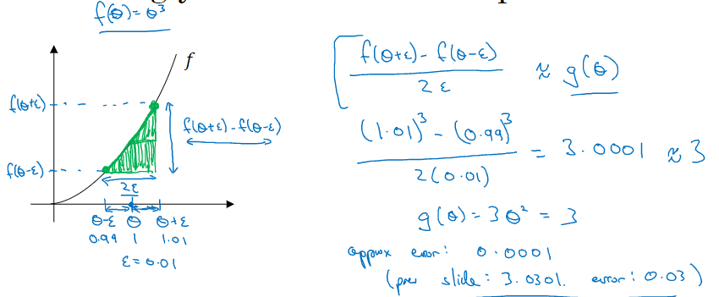
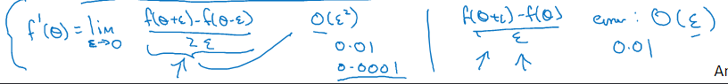

Optimization algorithms

Mini-batch gradient descent
- How it looks
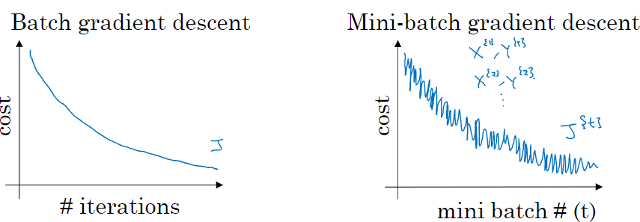

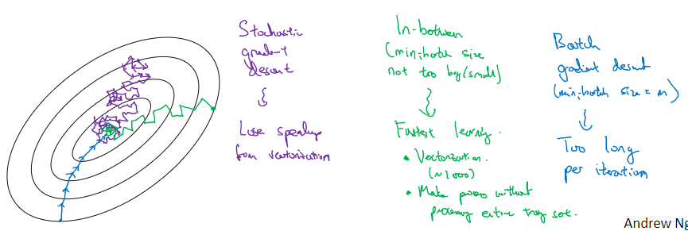
- Choose size
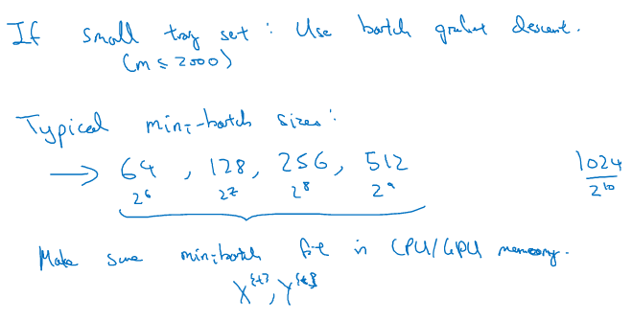

Exponentially weighted average
- Just like filtering
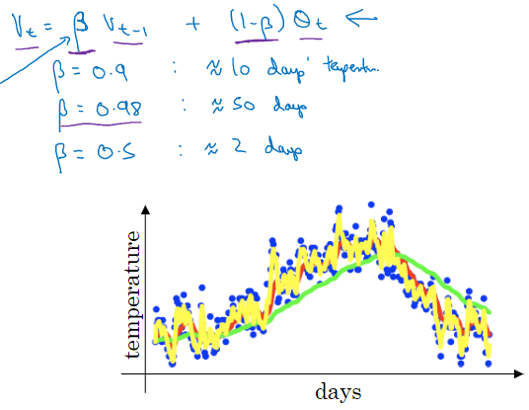
Close data gets more weight and vice versa
- Bias correction
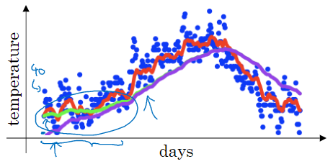
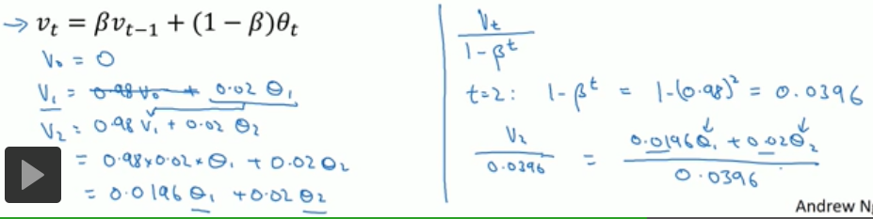

Gradient descent with momentum
- How it works
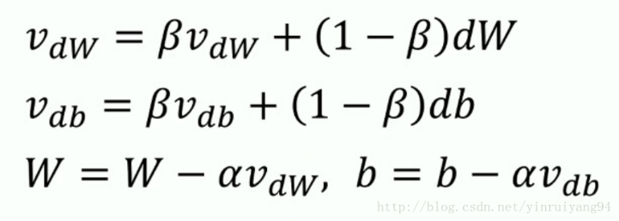
每一次梯度下降都会有一个之前的速度的作用，如果我这次的方向与之前相同，则会因为之前的速度继续加速；如果这次的方向与之前相反，则会由于之前存在速度的作用不会产生一个急转弯，而是尽量把路线向一条直线拉过去。
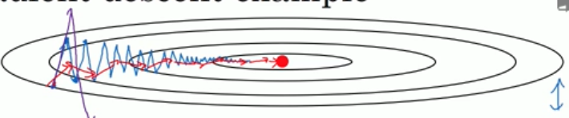

RMSprop
- How it works
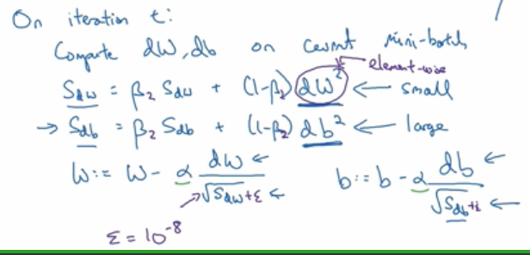

Adam
- Combines RMSprop and momentum
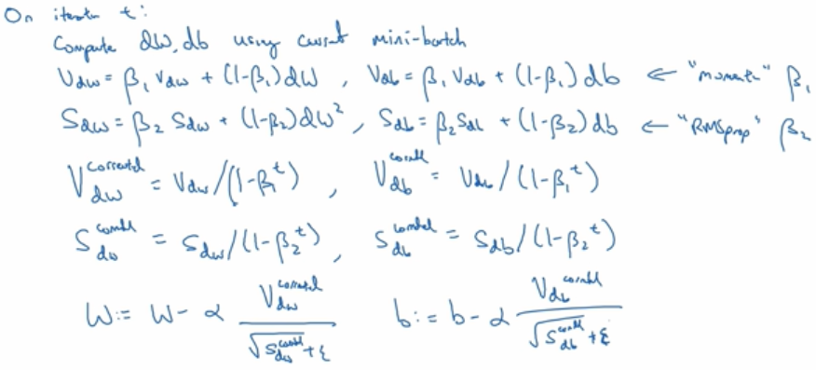

Learning rate decay
- In tensorflow
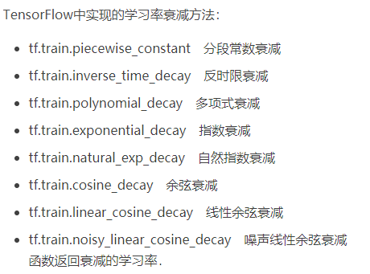
- Some types
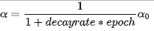
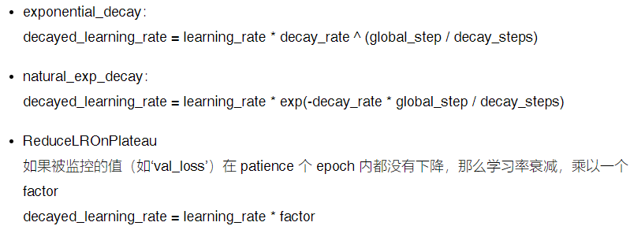

Local optimum
- 1
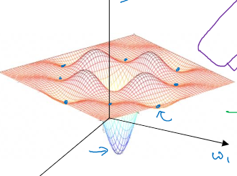
- Plateau (saddle point)
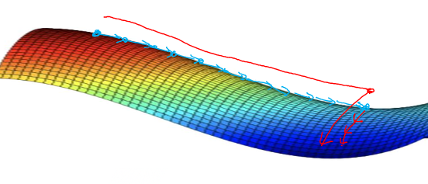
Unlikely to get stuck in high-dimensional spaces;
Will slow down learning

Hyper parameter tuning

Tuning process
- What to tune
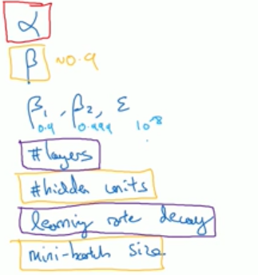red -> yellow -> purple
- How
Do not use a grid; choose random values. Because you do not know which parameters are more important beforehand. Then, coarse to fine sample.
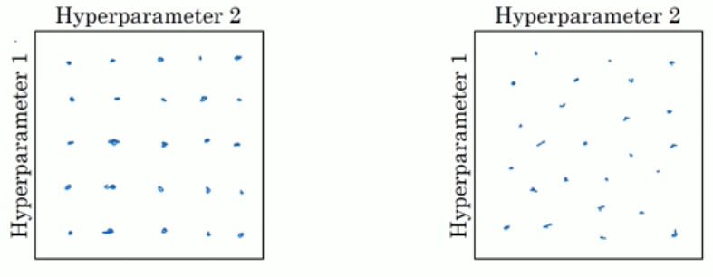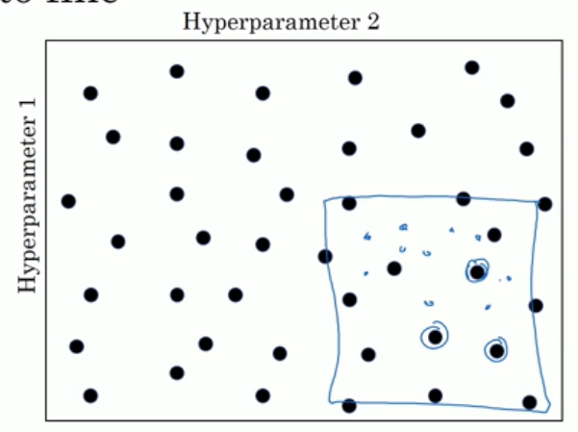

Using appropriate scale to pick hyperparameters
- Uniform scale does not allocate resources reasonably; a log scale is more ideal
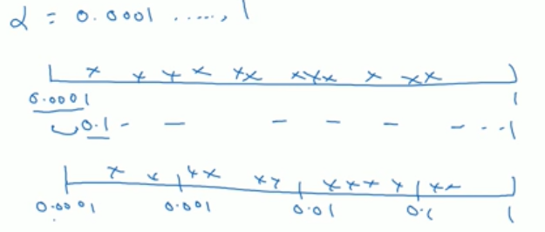

Parameters search in practice: pandas vs caviar
- 2 types
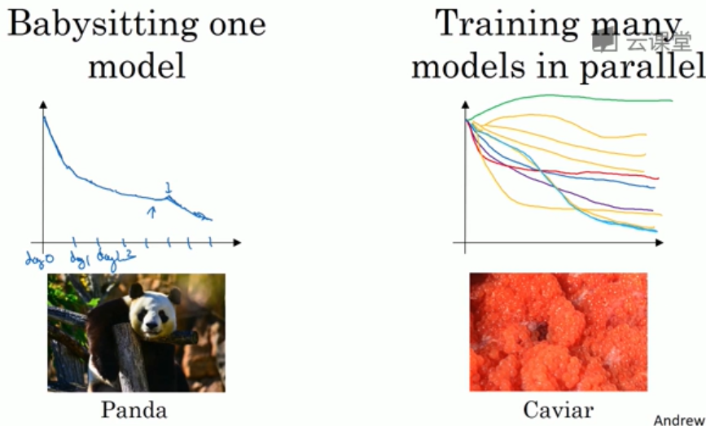

Normalizing activation (Batch-norm)
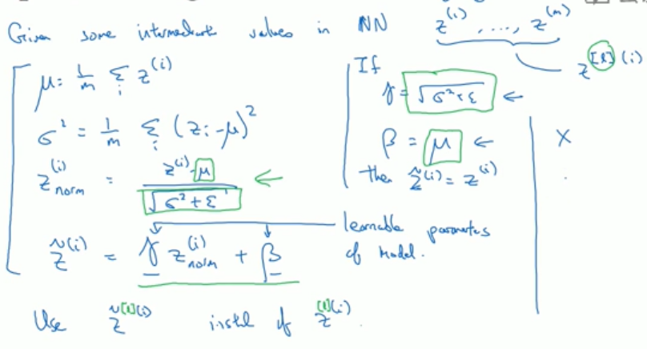

why batch-norm works?
- Learning on a shifting distribution
e.g. black cat and colorful cat
- What does it do?
Parameters may change, but mean and deviation remain intact, making them more stable.
- Batch-norm as regularization
